PROCESS | START |  | ASSEMBLY BY | Short block
PROCESS | FINISH |  | ASSEMBLY BY | Main Line

Firiing Order |  | 1 – 5 – 3 – 6 – 2 – 4 | All dimensions in millimetres
Valve Clereance | Intake | 0.35 ± 0.02 | All torques in Kilogram metres
Valve Clereance | Exhaust | 0.57 ± 0.02 | All torques in Kilogram metres

No. | PARTS | CHECK | CONDITIONS TO BE CHECKED |  |  |  |  | SPEC. | SIGN |  |  |  |  |  | SKETCH DRAWING or PHOTOES
 |  | POINT |  |  |  |  |  | SPEC. | MEC |  | QA |  | SPV |  | SKETCH DRAWING or PHOTOES
1 | Cylinder  Block | Bores | Check that the liner counter bore is clean |  |  |  |  |  |  |  |  |  |  |  | 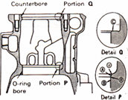
 | Cylinder  Block |  | and serviceable prior to fitting liner.
 |  | Inside of | Check that all oil holes are free from
 |  | oil hole | foreign matter such as chips or dirt.
 |  | U-plugs & | Make sure that all U-plugs and blind
 |  | blind plugs | plugs have been installed.
 |  |  | Make sure that Cyl. block condition is ready to used completely |  |  |  |  | - ~ 2.0 kgm  (Komatsu assembly manual)  THE OTHERS PLUG, SEE PLUG TABLE FOR TIGHTEN
 |  |  | - Tightening plug :
  Hexagon plug 5 mm | Act : kgm
• Oversize head gasket required:

Yes | No

 |  | Liner deck | See that three bondLG-6 has been applied to the proper area.
 |  | portion
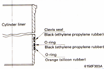  2 | Cylinder  Liner | Crevice  seal  O-rings | Check that the chamfered side is facing down. |  |  |  |  |  |  |  |  |  |  |  | 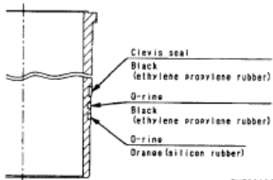  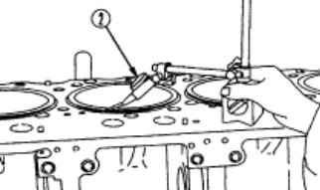
 | Cylinder  Liner |  | Check that the colour of the bottom O-ring is orange
 |  |  | Apply oil immediately before installing.
 |  |  | Set the “T” mark on the top surface of the liner facing the front.
 |  | Liner | Using a cloth, wipe off dirt and oil from contact surface
 |  |  | of liner lip and cylinder block counterbore.
 |  | Liner  Protrusion | Check the protrusion of the liner: |  |  |  |  | 0.08 ~0.18mm  (Shop Manual Page. 50-4)
 |  | Liner  Protrusion
  Cyl. | 1 | 2 | 3 | 4 | 5 | 6
  Act.
3 | Crank shaft | Crank | Make sure that stamp mark on Crank Shaft is available. |  |  |  |  | STD or  US 0.25  US 0.50 |  |  |  |  |  |  | 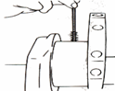  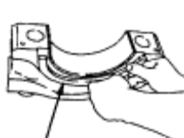  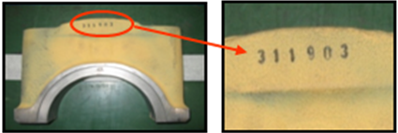
 | Crank shaft | Main | Check that there is no dirt at the rear face of the bearing |  |  |  |  | STD or  US 0.25  US 0.50
  STD | 0.25 | 0.50
 | Crank shaft | Bearings |  |  |  |  |  | STD or  US 0.25  US 0.50
 | Crank shaft |  | before tightening. Coat the inside face with  engine oil.  Do no coat the rear surface of the bearing  • Upper bearing has oil hole  • Lower bearing has no oil hole |  |  |  |  | STD or  US 0.25  US 0.50
2.7~3.4 mm
(Shop Manual Page. 50-5)
 |  |  | - Protrusion of Dowel Pin  *Make sure the number of main cup same  with S/N Engine Block. |  |  |  |  | 2.7~3.4 mm  (Shop Manual Page. 50-5)
  Act : mm
No. | PARTS | CHECK | CONDITIONS TO BE CHECKED |  |  |  |  | SPEC. | SIGN |  |  |  |  |  | SKETCH DRAWING or PHOTOES
 |  | POINT |  |  |  |  |  | SPEC. | MEC |  | QA |  | SPV |  | SKETCH DRAWING or PHOTOES
 | Crank shaft  Cont. | Thrust  bearing | Install the thrust bearing with the groove  on the crankshaft side. |  |  |  |  |  |  |  |  |  |  |  | 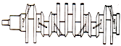
4 | Crank shaft  Cont. | Thrust  bearing |  |  |  |  |  |  |  |  |  |  |  |  | 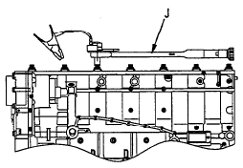  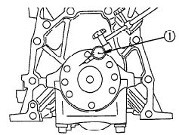
  Front
  Face run out
  Radial run out
  Rear
  Face run out
  Radial run out
 | Crank shaft  Cont. |  | Bolts must be oiled. When tightening,  start from the center and work in order to the Outside
 | Crank shaft  Cont. | Torque of  Bearing  Cap
 | Crank shaft  Cont. | Torque of  Bearing  Cap | Using limit length (a) of bolt stem:
 | Crank shaft  Cont. |  | 1st step : Act : kgm |  |  |  |  | 11~ 13 Kgm
 | Crank shaft  Cont. |  | 2nd step: Act : kgm |  |  |  |  | 21.5~22.5Kgm
 | Crank shaft  Cont. |  | 3rd step : Act : ⁰ |  |  |  |  | 90 ~120 ⁰  (Shop Manual Page. 50-6)
 | Crank shaft  Cont. |  | * After tightening bolt, make 1 punch mark  on the head of each bolt. (Don’t make a  punch mark when using a new bolt)  * Punch mark max. 5 punch marks.
 | Crank shaft  Cont. | Seal | Clean of all dirt and dust on the contact surface of the front and rear seals
 | Crank shaft  Cont. | Surface
 | Crank shaft  Cont. |  | Measure crankshaft End Play with dial gauge
 | Crank shaft  Cont. | End Flay | Act : mm |  |  | • Tolerance: |  | 0.140 -0.315 mm  (Shop Manual Page. 50-6)
 | Crank shaft  Cont. |  | Check that shaft turns smoothly  • Standard rotating force:
 | Crank shaft  Cont. |  |  | Act : kgm |  |  |  | 2.8 Kgm  (Reman Standard)
5 | Piston and  Con. rods | Piston | When assembling a new connecting rod,  mark the cylinder number with an electric punch. Do not make a stamped mark. |  |  |  |  |  |  |  |  |  |  |  | 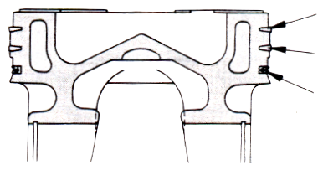  Top  2nd  Oil
5 | Piston and  Con. rods | Piston | Set up each ring with the stamped mark facing up. Note the position of the ring gap. |  |  |  |  | top ring: 1RS second ring: 2RX
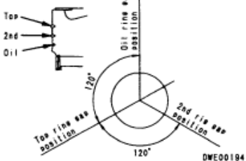

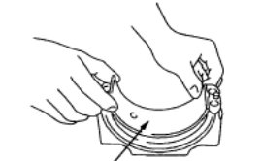
5 | Piston and  Con. rods | Piston | For the oil ring, take out the expander and install it into the piston, then install the oil ring.
5 | Piston and  Con. rods | Piston | Confirm that the expander is properly fitted to the groove.
5 | Piston and  Con. rods | Snap | Assemble piston and connecting rod.
5 | Piston and  Con. rods | ring | Confirm that the snap ring which secures  the piston pin is properly fitted to the grove.  Check that the connecting rod moves smoothly  Check size of main bearing
  STD | 0.25 | 0.50
5 | Piston and  Con. rods | Con. rod  Bearing
 | Piston and  Con. rods |  |  |  |  |  |  | STD or  US 0.25  US 0.50
No. | PARTS | CHECK | CONDITIONS TO BE CHECKED |  |  |  |  | SPEC. | SIGN |  |  |  |  |  | SKETCH DRAWING or PHOTOES
 |  | POINT |  |  |  |  |  | SPEC. | MEC |  | QA |  |  | SPV | SKETCH DRAWING or PHOTOES
6 | Piston and  Con. rods cont. | Con. rod  Bearing | Match the number of con. Rod are aligned Check that there is no dirt at the rear face of |  |  |  |  |  |  |  |  |  |  |  | 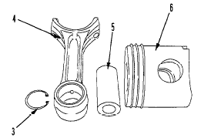  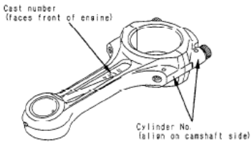  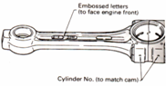  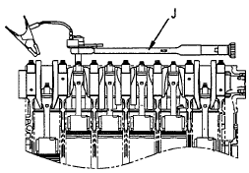  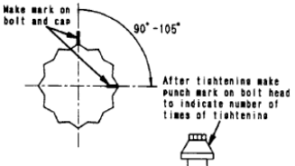
 | Piston and  Con. rods cont. |  | the bearing before assembling.
  CYL | 1 | 2 | 3 | 4 | 5 | 6
  UP
  LOW
 | Piston and  Con. rods cont. |  | Do not coat the rear surface bearing with oil.
 | Piston and  Con. rods cont. | Inserting  Piston &  Con. Rod | Check that the hole in the upper bearing and the oil hole in the co. rod are aligned.  Set the cylinder block on its side so that the assembly does not enter the cylinder suddenly when inserted.
 | Piston and  Con. rods cont. | Inserting  Piston &  Con. Rod | Coat the cylinder liner with engine oil (SAE 15W-40)  uniformly around the whole circumference by Hand.
Check that number of piston and connecting
rod assembly match cylinder number.
 |  |  | Coat connecting rod lower bearing with engine oil, spreading over whole part with finger.
 |  |  | Con rod bolts are to have oil (SAE15W-40) on the threads and under the washers.
 |  | Big End | 1st step: Act : kgm |  |  |  |  | 12.5 ± 0.5 kgm  (Shop Manual Page. 50-8)
 |  | Torque | 2nd step: Act : ° |  |  |  |  | 90⁰ ~ 120⁰
 |  |  |  |  |  |  |  | (Shop Manual Page. 50-8)
 |  |  | After tighten of bolt, make 1 punch mark on
 |  |  | the head of each bolt (Don’t make a punch
 |  |  | mark when using a new bolt)
 |  |  | * Punch mark max. 5 punch marks.
 |  |  | Measure con rod side clearance |  |  |  |  |  |  |  |  |  |  | 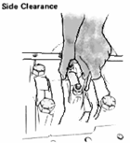
0.100~ 0.274
mm
(Shop Manual Page. 50-9)

CYL | 1 | 2 | 3 | 4 | 5 | 6
Act.

No. | PARTS | CHECK | CONDITIONS TO BE CHECKED |  |  |  |  | SPEC. | SIGN |  |  |  |  |  | SKETCH DRAWING or PHOTOES
 |  | POINT |  |  |  |  |  | SPEC. | MEC | QA |  | SPV |  |  | SKETCH DRAWING or PHOTOES
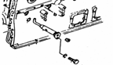  7 | Piston and  Con. rods cont. |  | Recheck/pastikan bahwa posisi piston sudah benar (dilihat dari posisi top).  * Cowakan yang lebih dalam ada di sisi intake  * Cowakan yang dangkal ada di sisi exhaust |  |  |  |  |  |  |  |  |  |  |  | 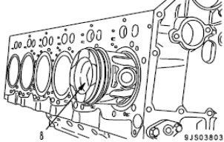  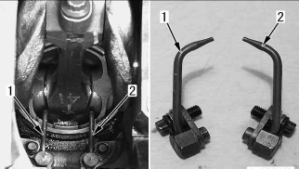
  CYL | 1 | 2 | 3 | 4 | 5 | 6
  Act.
 | Piston and  Con. rods cont. |  | Check that the piston cooling nozzle is not clogged and that the angle is correct and Install to Block.  Tightening torque
  Act : kgm
 | Piston and  Con. rods cont. | Piston Cooling  Nozzle |  |  |  |  |  | 5.5 ± 2.0 Kgm  (Shop manual Page. 50-9)
8 | Timing gear | Main Idler | Align “A” mark on crankshaft gear with “A”  mark on main idler gear (2), then tighten mounting bolts.  Tightening torque :  Small bolt  Step 1  Step 2 |  |  |  |  | 3.2 ± 0.3 kgm  ( Shop Manual Page. 50-10)  27 – 35 Kgm  90 ° - 120° |  |  |  |  |  |  | 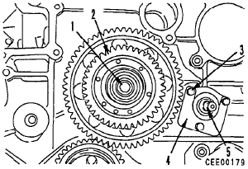
  Act : kgm
  Act : kgm
  Act : Kgm
 |  | Torque Bolt
 |  | Fuel Injection Pump | Fit key to shaft, align “C” mark of main idler  gear ‘with “C” mark of drive gear, then fit drive  gear (2) and tighten nut (I).  Torque bolt |  |  |  |  | 23 – 26 kgm  ( Shop Manual Page. 50-10) |  |  |  |  |  |  | 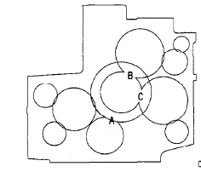
  Act : kgm
9 | Oil Pump Assy | Pump | - Check all of pump condition |  |  |  |  |  |  |  |  |  |  |  | 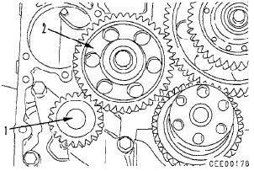
  Oil Pump | New | Reuse
 |  |  | - Fill in oil engine to inner of pump
 |  |  | - Rotate pump by hand smoothly
 |  |  | - Fit oring for sensor side
 |  |  | - Mounting oil pump(1) and tighten mounting  bolts. |  |  |  |  | 10~12.5 kgm
 |  |  |  |  |  |  |  | ( Shop Manual Page. 50-10)
  Act : kgm
 |  |  | - Mounting oil pump idler (2)and tighten mounting bolt |  |  |  |  | 38.5 – 43.5 kgm
 |  |  |  |  |  |  |  | ( Shop Manual Page. 50-10)
  Act : kgm
No. | PARTS | CHECK | CONDITIONS TO BE CHECKED |  |  |  |  | SPEC. | SIGN |  |  |  |  |  | SKETCH DRAWING or PHOTOES
No. | PARTS | POINT |  |  |  |  |  | SPEC. | MEC | QA |  | SPV |  |  | SKETCH DRAWING or PHOTOES
10 | Camshaft |  | Coat camshaft journal surfaces with engine oil  (SAE#30). Align “B” mark of camshaft gear with  “B” mark of main idler gear, then tighten  mounting bolts (3) of camshaft (4). |  |  |  |  |  |  |  |  |  |  |  | 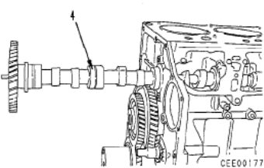
 |  |  | Mounting bolt of camshaft plate: |  |  |  |  | 10 ~12.5 kgm  (Shop Manual page. 50-11)
  Act : kgm

Timing Gear Marked |  | Check Point |  | Backlash (mm) |  | SIGN |  |  | SKETCH DRAWING or PHOTOES
 |  |  |  | Standard | Measured | MEC | QA | SPV | SKETCH DRAWING or PHOTOES
A |  | Crank Gear and Main idler gear (large ) |  | 0.141 ~ 0.425 |  |  |  |  | 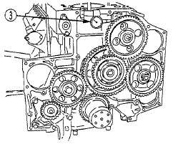  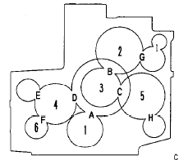
B |  | Main idler gear (small ) and cam shaft gear |  | 0.129 ~ 0.391
C |  | Main idler gear (small ) , injection pump drive gear |  | 0.129 ~ 0.391
D |  | Main idler gear (large) and sub idler gear |  | 0.141 ~ 0.426
E |  | Sub Idler gear and water pump drive gear |  | 0.095 ~ 0.346
F |  | Sub Idler gear and oil pump drive gear |  | 0.080 ~ 0.417
G |  | Cam shaft gear and air compresor drive gear |  | 0.118 ~ 0.369
H |  | Injection Pump drive and PTO gear(lower) |  | 0.118 ~ 0.369
I |  | Compresor drive gear and PTO gear(upper) |  | 0.025 ~ 0.486
Check Point |  |  |  | End Play (mm)
 |  |  |  | Standard | Measured
1 |  | Camshaft gear |  | 0.10 ~ 0.250
2 |  | Main idler gear |  | 0.05 ~ 0.170
3 |  | Sub Idler gear |  | 0.05 ~ 0.170
4 |  | Injection pump drive gear |  | 0.070 ~ 0.200
5 |  | Oil pump idle gear |  | 0.030 ~ 0.088
No. | PARTS | CHECK | CONDITIONS TO BE CHECKED |  | SPEC. | SIGN |  |  | SKETCH DRAWING or PHOTOES
No. | PARTS | POINT |  |  | SPEC. | MEC | QA | SPV | SKETCH DRAWING or PHOTOES
11 | Gear Case Cover |  | Fit gasket, install gear case cover (I).  * When installing the gear case cover, remove  the service meter gear box. After installing  gear case cover, install service meter gear box. |  |  |  |  |  | 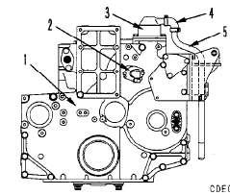
 |  | Front Seal | Check front seal specification  Press in the front seal uniformly so that it is not at an angle. |  | STD or  OVER SIZE  S = Single Lip Seal  W= Double Lip Seal |  |  |  | 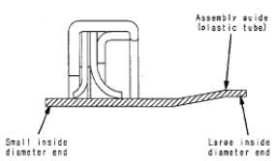
  S/W | STD | OS
 |  | Breather | Fit O-ring, install breather (3).  Torque mounting bolt:  2) Install hose (4) and tube (5), then secure  with clamps. |  | (2.5 - 3.0 kgm)
  Act : Kgm
No. | PARTS | CHECK | CONDITIONS TO BE CHECKED |  | SPEC. | SIGN |  |  | SKETCH DRAWING or PHOTOES
No. | PARTS | POINT |  |  | SPEC. | MEC | QA | SPV | SKETCH DRAWING or PHOTOES
12 | Flywheel  Housing | assembly | No crack and no damage  No damage thread hole  Coat with gasket sealant (LG-7), then raise  flywheel housing and install  Coat mounting bolt with engine oil SAE15W~40  Tighten the flywheel housing mounting bolts in order from diagram. Oil bolt threads. |  |  |  |  |  | 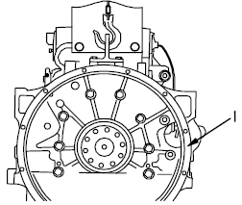  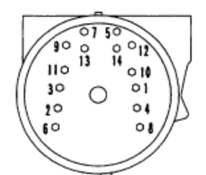
 |  |  | 1st step: Act : kgm |  | 15 ~ 24 kgm
 |  |  | 2nd step: Act : kgm |  | 25 - 31.5 kgm  (Shop Manual Page. 50-18)
 |  | Rear Seal | Make sure that the rear seal No pitting,  No scratch. Press fit the rear seal by using installation tool to obtain correct position. Be careful not to damage the seal when installing the housing.
  S/W | STD | OS
STD or
OVER SIZE
S= Single Lip
W= Double Lips
13 | Oil Pan |  | - Install the O-ring and suction tube (1),  - Install bracket (2) to the cylinder block.  - Recheck Condition 0f Oil Pan  (No crack , No band and No damage)  - Install the gasket and push up oil pan (1)  with a pallet lift, etc. and tighten the  mounting bolts  - Connect the level sensor connector.  - When tightening, start from center and work in order to  the out side. |  |  |  |  |  | 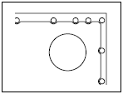  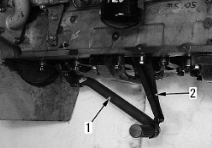  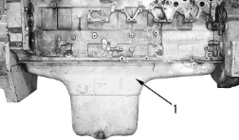
  Oil Pan | New | Reuse
 |  |  | - Tighten mounting bolts. |  | 6.5 ± 1 Kgm  ( Shop Manual Page. 00-24)
  Act : kgm
14 | Vibration Dumper Ass’y |  | Matching the dowel pin of damper assembly (1),  tighten 6 mounting bolts.  Tightening Mounting bolt: |  | 25. ~ 31.5 kgm  (Shop Manual page. 50-13) |  |  |  | 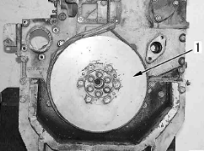
  Act : kgm
15 | Front Support |  | Apply grease (G2-L1) to the lip of the oil seal
 | Front Support |  | Take care not to roll up the lip |  |  |  |  |  | 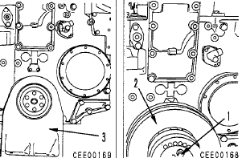
 | Front Support |  | Tighten mounting bolts
 | Front Support |  |  |  | 10 ~ 12.5 Kgm  ( Shop Manual Page. 00-24)
  Act : kgm
No. | PARTS | CHECK | CONDITIONS TO BE CHECKED |  | SPEC. | SIGN |  |  | SKETCH DRAWING or PHOTOES
No. | PARTS | POINT |  |  | SPEC. | MEC | QA | SPV | SKETCH DRAWING or PHOTOES
16 | Flywheel |  | -Using eye bolt  @ (Dia. = 12 mm, Pitch = 1.75 mm),  -Sling flywheel , install the flywheel to the crankshaft,  -Coat the threads of the bolts and the  seat face, with engine oil 15W40  * Make a punch mark on the bolt head each time the bolts are used.  Fly wheel mounting bolts : |  |  |  |  |  | 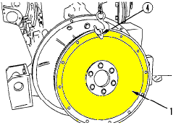  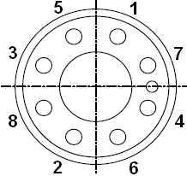
 |  |  | 1st Torque: Act : kgm |  | 11.5 ~ 12.5 Kgm
 |  |  | 2nd Torque: Act : ⁰ |  | 90°~120⁰  ( Shop Manual Page. 50- 21)
17 | Cam  Follower | assembly | Before installing the cam follower assembly, |  |  |  |  |  | 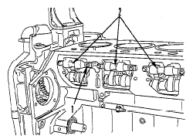  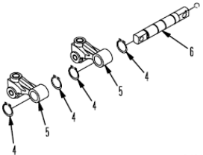
 | Cam  Follower |  | Wash the oil hole of the mounting bolt.
 | Cam  Follower |  | Make sure that the oil hole is free from dirt.
 |  |  | Use LG-7 liquid gasket on the cover face.
 |  | Torque | Torque the cam follower mounting bolt . |  | 4.5 ~ 6.0 kgm  (Shop Manual page. 50-11)
  Act : kgm
 |  |  | Torque the cover plate mounting bolts. |  | 1.0 ~ 1.3 Kgm
 |  |  |  |  | ( Shop Manual Page. 50-11)
  Act : kgm
19 | Oil cooler assy |  | Fit gasket and install oil cooler assembly (I).  * When installing therm0 valve, confirm the  protrusion amount of spring. Fit spring again  when exceeding standard value.  Protrusion amount of spring a: 24 mm |  |  |  |  |  | 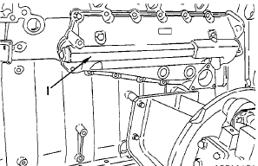
20 | Water Pump |  | Fit O-ring and install water pump assembly  (2).  * The mounting bolts of the water pump  are used to tighten the gear case.  2) Fit gasket and install tube (I).  Tightening torque |  | 6.7 ± 0.7 Kgm |  |  |  | 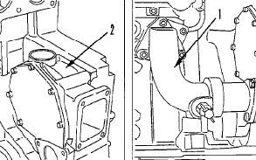
  Act : Kgm
21 | Termostat housing |  | Fit O-ring to tube (21, then install to  thermostat housing (4).  Fit gasket and install thermostat housing (4)  with mounting bolts (3).  Move tube (2) down and install ring (I).  Tightening torque |  | 6.7 ± 0.7 Kgm |  |  |  | 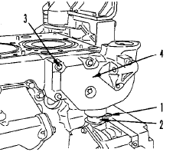
  Act : Kgm
22 | Cylinder |  | - Check that there is no dust or dirt inside the cylinder and on mounting surface.  - When installing the gasket, check that the  grommet has been fitted and has not  come  - The grommets in the head gasket may become deformed by swelling, so do not coat them with gasket sealant.  - Check and mark grommet with white marker. |  |  |  |  |  | 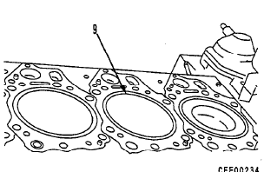
  Cyl. | 1 | 2 | 3 | 4 | 5 | 6
  Check
 | Head
 |  | Grommets
No. | PARTS | CHECK | CONDITIONS TO BE CHECKED |  | SPEC. | SIGN |  |  | SKETCH DRAWING or PHOTOES
No. | PARTS | POINT |  |  | SPEC. | MEC | QA | SPV | SKETCH DRAWING or PHOTOES
23 | Cylinder  Head  Cont. | O/S head  gasket | If oversize head gaskets are to be fitted, the block must be stamped O/S. |  | STD or OVER SIZE |  |  |  | 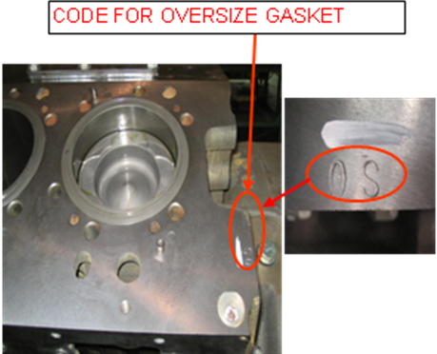  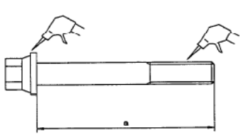
  STD | OS
 |  | Bolts | -The head bolts must have no dirt in the  threads or under the washer, or in the  threaded holes in the block.
 |  |  | -Coat the thread and bolt head with Oil.
 |  |  | The threaded holes in the block must be free from dirt. A tap can be used to clean the threads
 |  | Torque | Torque mounting bolt No.1- 6 :  Step : |  |  |  |  |  | 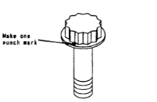  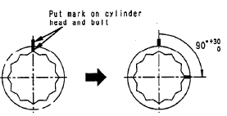  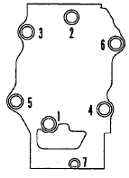
 |  |  | 1st Kgm |  | 14 ~ 16 Kgm
 |  |  | 2nd Kgm |  | 21 ~ 22.5Kgm
 |  |  | 3rd ⁰ |  | 90°-120°
 |  |  | Torque mounting bolt No.7 :  Torque in the order shown. |  | ( Shop Manual Page. 50-14)  6.8 ± 0.8 kgm  ( Shop Manual Page. 50-15)
  Act : kgm
 |  |  | Install heat label at cylinder head No.6
 |  |  |  |  | 99°c ~ 127°c (210°F ~ 260°F)
  Act : °
24 | Valve Mec-hanism | Cross  Heads | - Fit cross heads and adjust so that |  | 5.4 ~6.6 Kgm  ( Shop Manual Page. 50-15) |  |  |  | 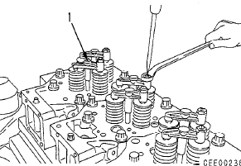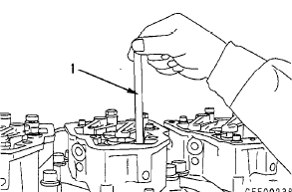
24 | Valve Mec-hanism |  | when the screw has touched the valve  stem it is advanced 20°.
24 |  |  | - Cross head adjusting screws go to  exhaust manifold side of head.  - Lock nut tighten torque:
  Act : kgm
24 |  | Push rod | - Install Push rod in the hole  * Check that the push rod is in the cam follower.
 |  | Rocker Arm housing | Fit gasket and install rocker arm housing  Mounting bolt: |  | (6.0 - 7.5 kgm) |  |  |  | 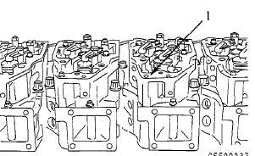
  Act: Kgm
No. | PARTS | CHECK | CONDITIONS TO BE CHECKED |  | SPEC. | SIGN |  |  | SKETCH DRAWING or PHOTOES
No. | PARTS | POINT |  |  | SPEC. | MEC | QA | SPV | SKETCH DRAWING or PHOTOES
25 | Valve Mec-hanism | Rocker Arm Assy | install rocker arm (3) and tighten with mounting bolts (2) and (I).  * Check that the ball of the adjustment screw is properly fitted into the socket of the push  rod. Then tighten bolts.  w Mounting bolt: |  | 9.50~ 10 .5 Kgm |  |  |  | 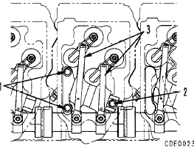
  Act : Kgm
25 |  | Valve clereance | Crank the engine and follow the firing order  to adjust the valve clearance of each cylinder.  Firing order: 1 - 5 - 3 - 6 - 2 - 4  Rotate the crankshaft in the normal  direction to align pointer (2) with the 1.6  TOP mark on vibration damper (I 1. When  rotating, check the movement of the  valves.  To adjust, insert feeler gauge I between  rocker arm (3) and crosshead (4) and turn  adjustment screw (5) until clearance is a  sliding fit.  Tighten locknut (6) to hold adjustment  screw in position.  Torque bolt,  Ir After tightening the  the clearance again.  lock nut, check |  |  |  |  |  | 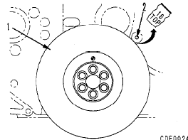  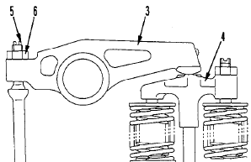
25 |  |  |  |  |  |  |  |  | 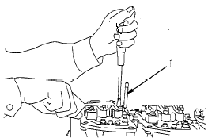
 |  |  | -Adjust valve clereance  Intake : |  | Intake 0.41 ~0.45 mm  Exhaust 0.78 ~ 0.82 mm
  Act : mm
-Adjust valve clereance.
Exhaust :
Act : mm

 |  |  | -Tighten locknut (6) to secure adjustment  screw (5)  -Locknut: |  | 5.4 ~6.6 Kgm |  |  |  | 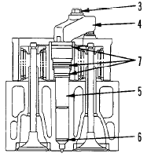  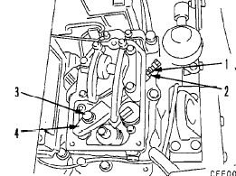  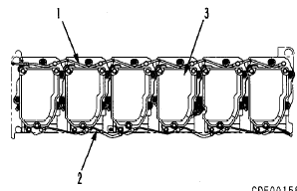
  Act : kgm
 |  | Nozzle and Nozzle holder Assy | -Fit holder (41, then fit ball washer to  mounting bolt (3) and tighten mounting bolt.  Holder mounting bolt: |  | (6.0 - 7.5 kgm)
 |  |  | Tighten inlet connector  locknut (1)  Torque inlet connector:  (2),  Torque Inlet conector  Torque Locknut: |  | 3.5 - 4.0 kgm  3.0 - 3.5 kgm
  Act : Kgm
  Act : Kgm
  Act : Kgm
 |  | Rocker Arm housing cover | -Fit O-ring and install rocker arm housing  cover (3).  -Mounting bolt:  -Fit gasket on both sides and install spill pipe(2).  -Mounting bolt: |  | 1.5 ~ 3.5 Kgm  0.8 ~ 1.0 Kgm
  Act : kgm
  Act : kgm
-Fit gasket on both sides and install air vent
tube (1).
Mounting bolt:
Act : kgm

 |  |  |  |  | 1.0 ~ 1.3 Kgm
26 | Oil Pan | Suction Pipe  Oil Pan | -Fit O-ring, then fit suction pipe (2) and install bracket (I) to the under frame.  Torque bolt:  -Fit gasket and install oil pan (3).  Torque bolt : |  | 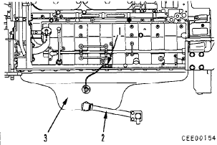  6.0 ~7.5 Kgm |  |  |  | 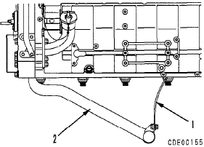
  Act : Kgm
  Act : Kgm
27 | PTO case tube, bracket |  | - Install fuel injection pump bracket (2).  Install turbocharger lubrication inlet tube (I).  -Turbocharger lubrication inlet tube  (Bracket side of tube):  Mounting bolt:  -Fit O-ring and install PTO case (3).  Mounting bolt: |  | 2.5 - 6 kgm  11.0 - 12.5 kgm} |  |  |  | 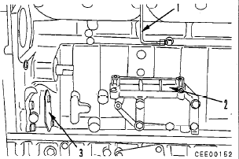
  Act : kgm
  Act : kgm
28 | Fuel injection pump |  | - Install flange coupling (IO) and front  laminated coupling (5) to fuel injection  drive shaft (12).  -Then align the stamped line “a” on the flange and line “b” on the flange of the pump.  Mounting bolt (14)  -Set the timing of the fuel pump injection timing.  -FIP Flange Mounting bolt :  -Fip Bracket Mounting bolt M 10  -Coupling lock bolt & Plate  -Fip Mounting Bolt M 10  Fuel injection tube |  | Std 16°  8.5 ~ 9.5 Kgm  6.7 ± 0.7 Kgm  8.5 ~ 9.5 Kgm  6.7 ± 0.7 Kgm  2.3 ~ 2.5 Kgm |  |  | 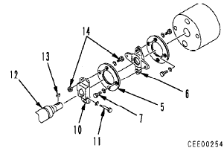  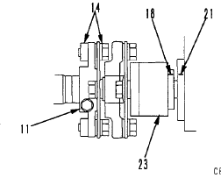 | 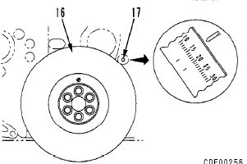
  Act : °
  Act : Kgm
  Act : Kgm
  Act : Kgm
  Act : Kgm
  Act : Kgm
29 | Aftercooler assembly |  | -Intake manifold mounting bolt torque : |  | 6.0 ~ 7.5 Kgm |  | 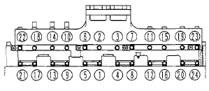
  Act : Kgm
30 | Exhaust Manifold |  | -Firstly tighten mounting bolts in order to shown in diagram, then tighten other  bolts. |  | 6.0 ~ 7.5 Kgm |  |  | 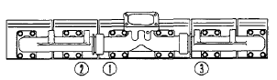
  Act: Kgm
31 | Turbo charger |  | -Fit gasket and install turbocharger (2) with mounting bolts (I).  Torque bolt : |  | 4.5 ~ 5.0 Kgm |  |  |  | 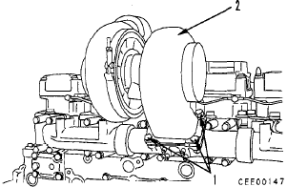
  Act : Kgm
32 | Alternator |  | -Install alternator, Alternator bracket & belts (5).  -Adjust belt tension with adjustment nuts (4) that deflection is 13 - 16 mm when pushed with a force 10 Kgm.  -Tighten bolts (I), (2) and (3). |  |  |  |  |  | 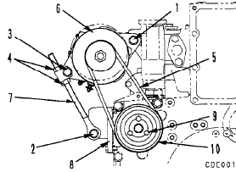
33 | Tension Pulley |  | -Install tension pulley assembly (5) with  mounting bolts (4).  -Set fan belt (3) on groove of pulley.  -Adjust fan belt tension with tightening  adjustment bolt (2) and move tension pulley toward outside that deflection is 13 - 15 mm (new belt) or 17 - 19 mm (when tension adjustment) when push a force 98 N {10 kg} at middle of fan belt (3), then tighten locknut (I). (Machine without auto-tension) |  |  |  |  |  | 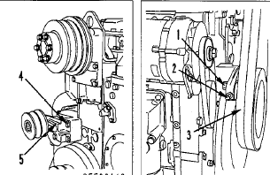
34 | Starting motor |  | Fit gasket and install starting motor (2) with mounting bolts (1).  Torque: |  | 20 Kgm |  |  |  | 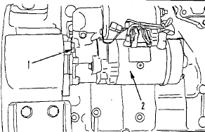
  Act : Kgm
 | Mufler assy |  | Coat all exhaust conection that has no gasket. With Fire sealant gum. |  | Sealant CP 25 WB |  |  |  | 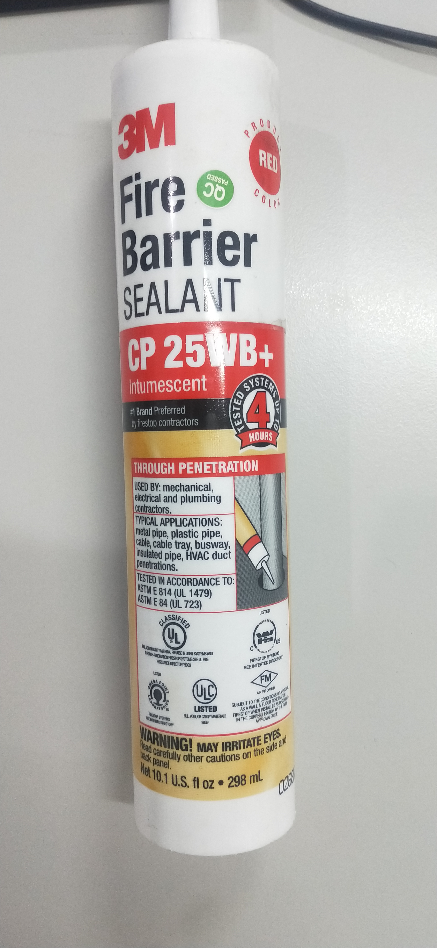  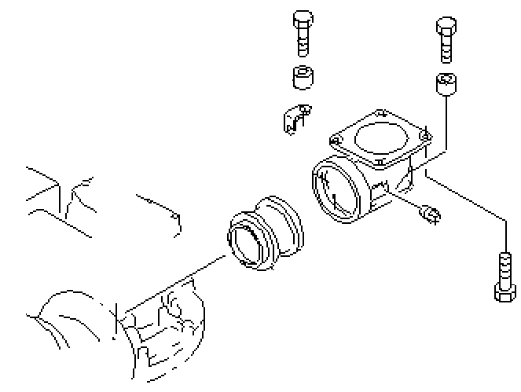

Injection timing |  |  | Notes :
Unit Model | Injection Timing (deg) |  | Notes :
GD 825-2 | 16
D155AX -5A | CRI
Comment :
ASSEMBLY BY | INSPECTED & APPROVED BY

MECHANIC (MEC) |  | QUALITY ASURANCE (QA) |  | PROD. SUPERVISOR (SPV)

